Project Planning Phase
Phase 4: Create Transform Map
The Project Planning Phase defines the activities, resources, timeline, and responsibilities required to successfully implement the Employee Data Import using Import Sets and Transform Maps project in ServiceNow. The planning ensures that the project is completed systematically and that the imported data is accurate and reliable.

1. Project Objectives
- Import employee data from an Excel spreadsheet into ServiceNow.
- Create and configure an Import Set Table.
- Create a Transform Map for source-to-target field mapping.
- Execute the transformation process.
- Validate the imported employee records.
- Identify and resolve data import errors.

2. Project Activities
Phase | Activity | Expected Outcome
1 | Prepare Excel data | Structured employee data is ready
2 | Create Import Set Table | Source data can be temporarily stored
3 | Load spreadsheet | Employee data is imported into ServiceNow
4 | Create Transform Map | Source and target tables are connected
5 | Configure field mappings | Fields are mapped correctly
6 | Execute Transform | Employee records are created/updated
7 | Validate records | Imported data is verified
8 | Error handling | Invalid or incorrect records are corrected
9 | Final verification | Data integrity is confirmed
10 | Documentation | Project process and results are recorded

3. Resource Planning
Software Resources:
- ServiceNow instance
- Microsoft Excel or compatible spreadsheet application
- Web browser
Technical Resources:
- Import Set Table
- Transform Map
- Target employee table
- Employee data spreadsheet
Human Resources:
- ServiceNow Administrator/Developer
- Project team member responsible for preparing and validating data

4. Timeline Planning
Task | Planned Duration
Requirement Analysis | 1 Day
Project Design | 1 Day
Excel Data Preparation | 1 Day
Import Set Configuration | 1 Day
Transform Map Configuration | 1 Day
Data Transformation | 1 Day
Testing and Validation | 1 Day
Documentation | 1 Day

5. Testing Plan
The following tests will be performed:
- Verify that the Excel file uploads successfully.
- Check whether all source records are loaded into the Import Set Table.
- Verify that each source field is mapped to the correct target field.
- Execute the Transform Map and check the transformation status.
- Verify that employee records appear correctly in the target table.
- Check for missing, duplicate, or invalid data.
- Confirm that the final record count matches the expected result.

6. Risk Management
Risk | Possible Impact | Mitigation
Incorrect spreadsheet format | Import failure | Validate the spreadsheet before upload
Incorrect field mapping | Wrong data in target table | Review Transform Map mappings
Missing required data | Incomplete records | Validate mandatory fields
Duplicate employee records | Data inconsistency | Use a unique employee identifier
Transformation errors | Records not imported correctly | Review transformation logs and errors
Create Transform Map
In this phase we need to create the Transform Map by clicking on the Create Transform Map button as shown in above screenshot.

Give inputs as shown below.
Name: Sample Spreadsheet Import
Source Table: Employee Import is auto-populated
Target Table: Employee Test - as we created earlier
Click on Auto Map Matching fields.

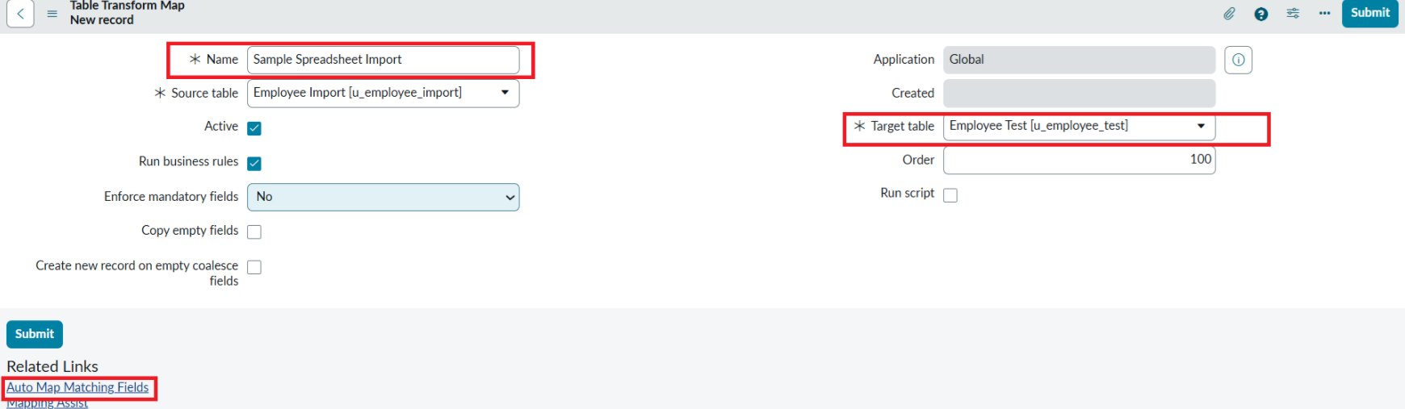

Now click on Mapping Assist and map the fields with Source & Target Table
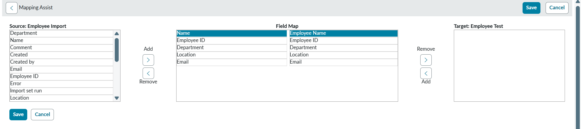
Click on Save

Make sure the both Source & Target table fields are mapped as shown below.
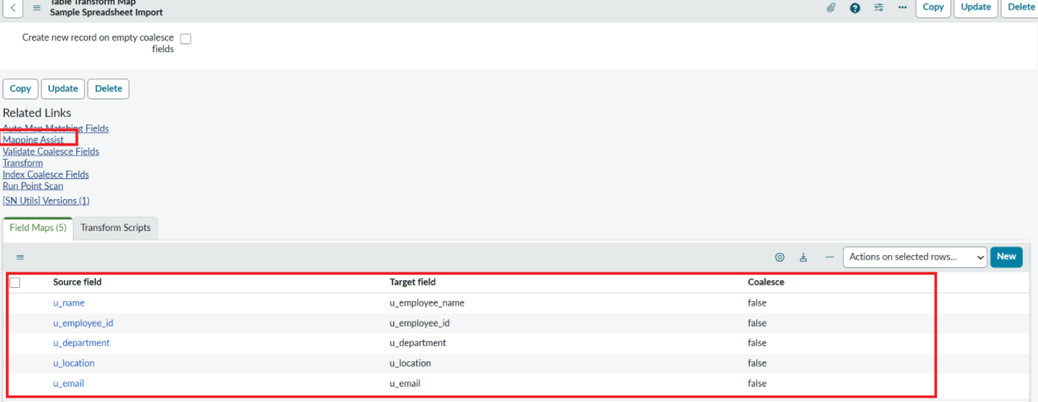

- Now click on Transform as shown below

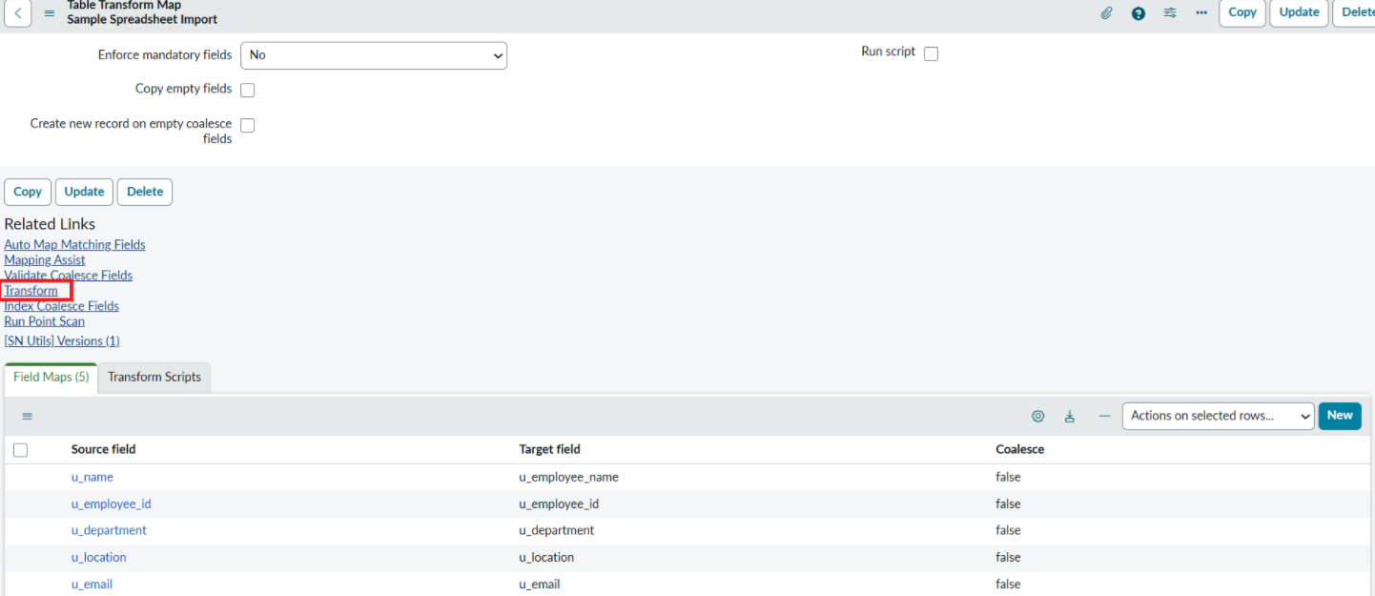

- Now click on Transform Button as shown below.

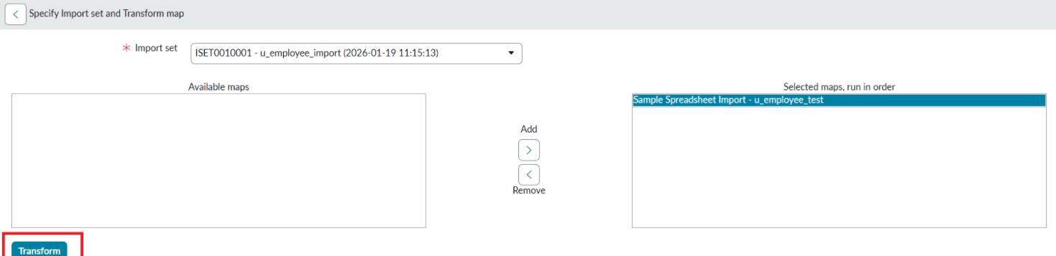

- After clicking Transform, make sure you see the success message as shown below.
